**Experiment 9**

**Aim**: A) Study of VI editor

**Theory:**

Three modes of operation:

1. command mode
2. insert mode
3. colon mode

           B) Write shell scripts to do the following:

1. **Display top 10 processes**

**ps -eo pid,ppid,cmd,%mem,%cpu | head;;**

     ps is performance monitoring tool stands for process status. The -o option of ps allows you to specify the output format, processes displayed by %mem and %cpu.

1. **Display current logged in user and logname**

    Environment variable $USERNAME and $LOGNAME displays the details of current user

1. **Display current shell, home directory, operating system type, current path, current working directory**

Following commands are used to display;

1. Current Shell - $SHELL
2. Home Directory - $HOME
3. Operating system type – uname -o
4. Current path - $PATH
5. Current Working Directory – $PWD
6. **Display OS version, release number, kernel version**

Following commands are used to display;

1. OS version - $ cat /proc/version
2. OS release number - uname -r
3. Kernel version - uname –v

**PROGRAM AND OUTPUT:**

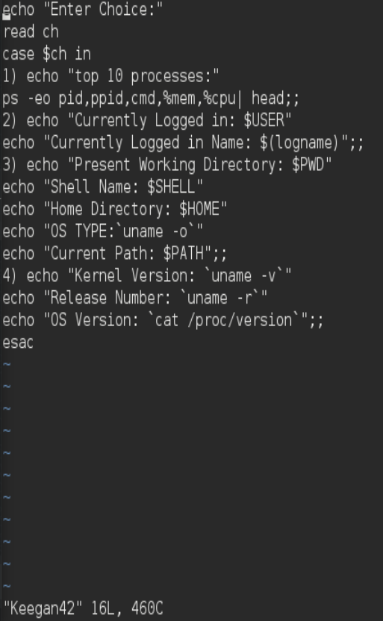

**Output:**

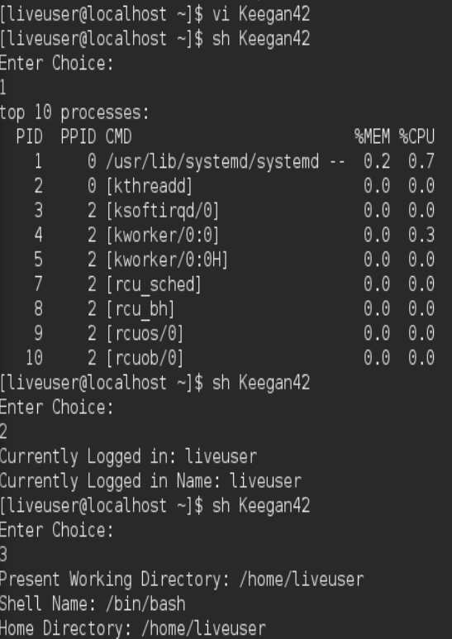

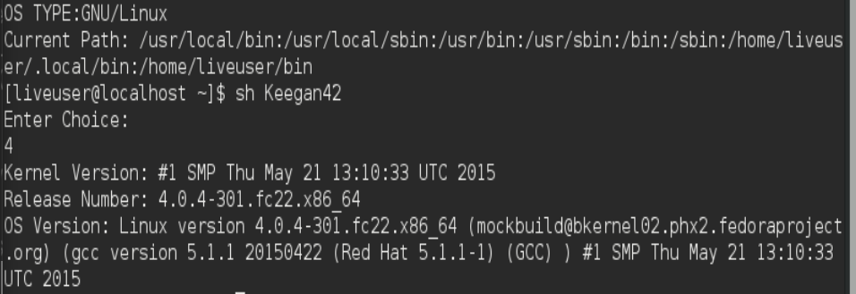

**CONCLUSION:**

Learnt to use a switch case statement and explored VI editor Commands.

**Post experiment exercise:**

Q1: What is the use of head and tail filters?

Shell provides us the head and tail commands to print only the lines in which we are interested in. The main difference between both the commands is, head prints the lines from the beginning of the files, and tail prints the lines from the end of the files.

Q2: What is pipe in shell programming?

The pipe character | is used to connect the output from one command to the input of another.